MenShen Manual
- Environment Requirement
Menshen runs in Linux x64(we recommend Ubuntu 14.04 x64). It runs with .Net framework 4.5.

- Programs Needed
- Mono (to run the GUI)
1.1 Version：4.2.1.102 or up（Lower versions may cause wrong behavior.）
1.2 Please refer to the installation guide of Mono for more information about how to install Mono. The website of Mono is http://www.mono-project.com.

- Redlog (In Reduce-Algebra)
2.1 Redlog is integrated in Reduce-Algebra now. Please refer to the installation guide for more information about how to install Reduce-Algebra. The website of Reduce-Algebra is http://www.reduce-algebra.com/index.htm.
2.3 You can find the button labeled “Set Redlog” in Menshen. Please click it, then select the folder that you install Reduce-Algebra.
If you install the “Reduce-Algebra” in folder “reduce-algebra” like this:
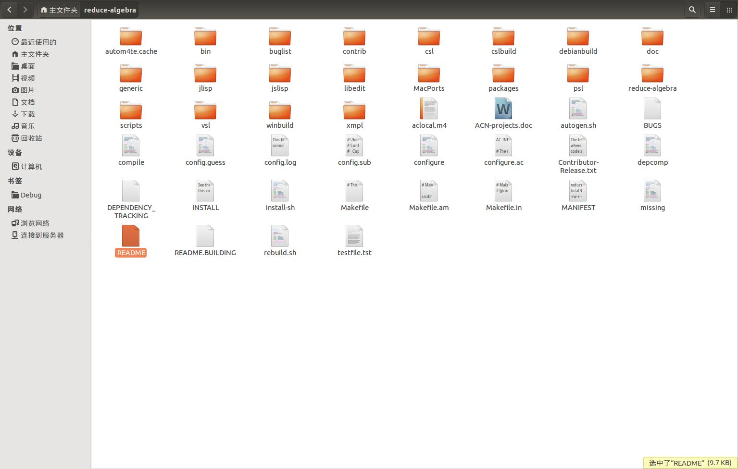
You can click the “Set Redlog” button in Menshen to configure the directory of Reduce-Algebra. Then, Menshen can call Redlog in the following checking phase:
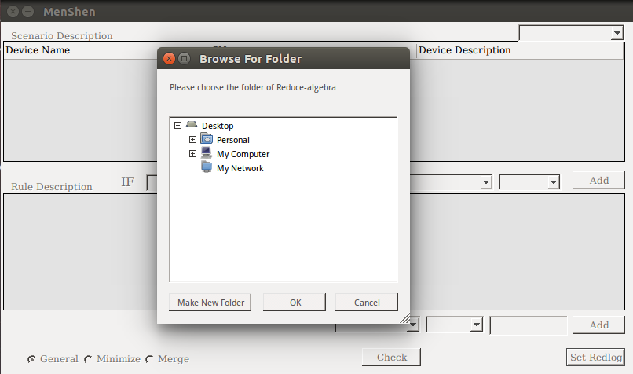

- Please make sure that you give file “BACH” and “SMT” in the folder “bin” permissions to execute.

- Instructions To Run MenShen
- Open MenShen
You need to go into the folder of MenShen and use command “mono Menshen” to open it.
- Instructions Step by Step
- The main frame of the checking view is shown below：
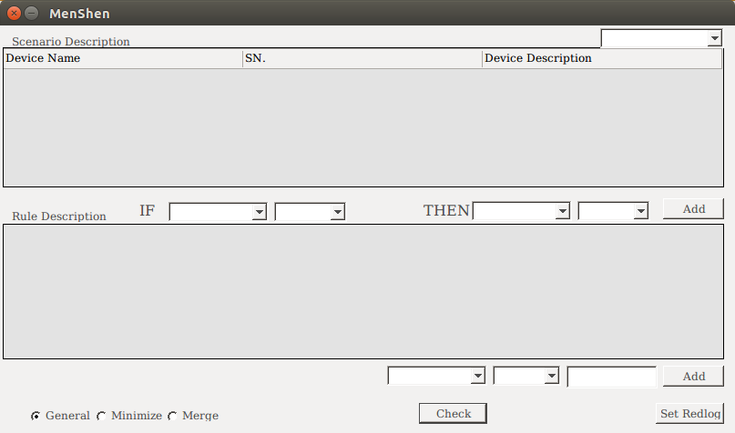
- After chose a case in the drop down list in the upper-right corner of the frame, you can see the description of the devices and rules related with this case:
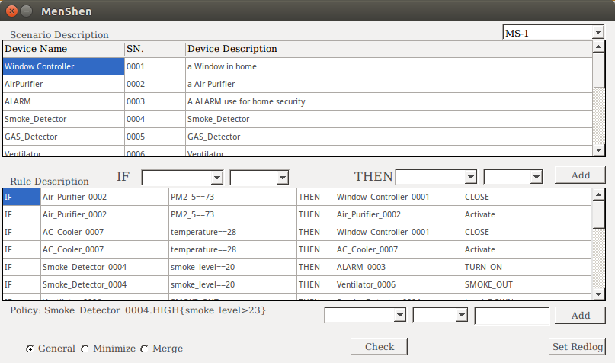
- You can click on the name of each device to see the detail description of the device. The detail of each device is shown in the following way. You can learn the working modes and APIs of devices. You can also click “Json File” to see the complete description file in Json format.
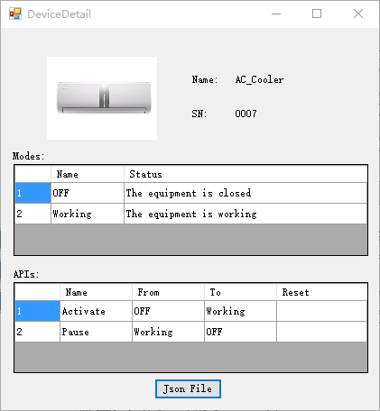
- We provide 3 different modes to perform the model checking procedure. You can select one of them and click the “Check” button.
- If MenShen finds a violation, a dialog stating there is a violation will pop up. You can try to modify the value of the triggering conditions to try to fix the system by yourself. You can also try the auto fixing procedure provided by MenShen.
- Before conduct the fixing procedure, you can click the “Fix Configuration” button, then select the set of rules you want to fix and also set the value range for the specific parameter.
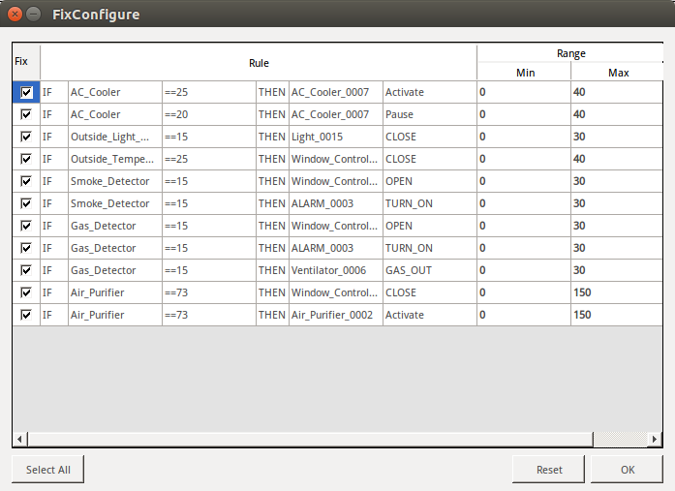
- Click the “Auto Fix” button, then MenShen can conduct the fixing procedure.
- The result of our fixing procedure is shown below. The values changed in the rules are labeled by red color. If you move your mouse into the row of this rule, you can also see the original value in this rule.
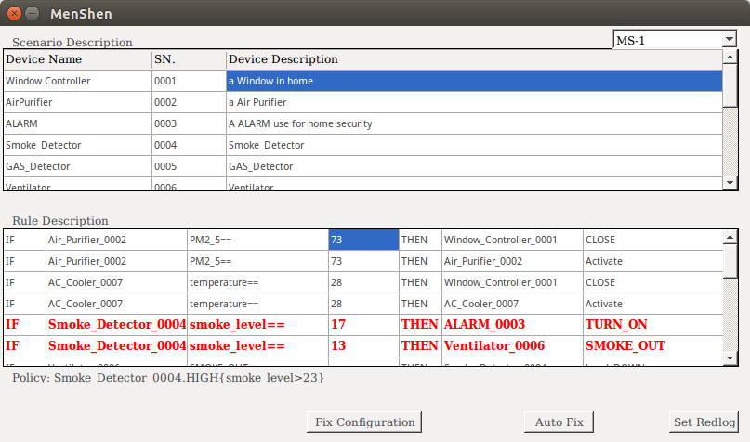
- If you are not satisfied with the results suggested by MenShen, you can change the value by yourself of course. Or, you can do the checking and fixing procedure again.
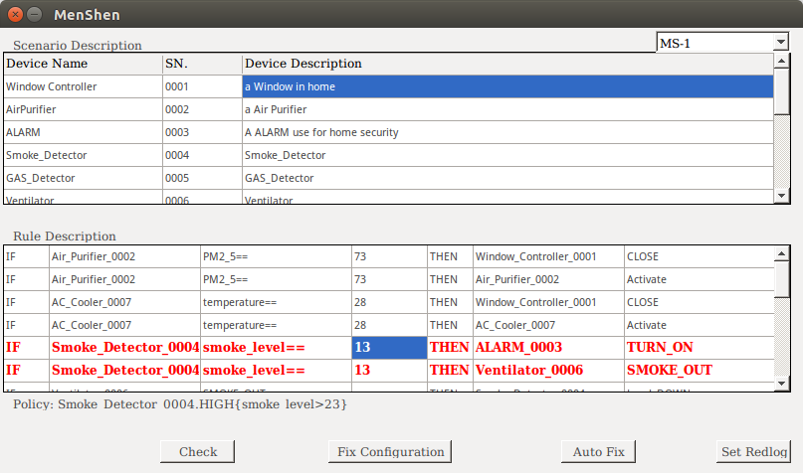

Note:
All experiments time usage shown in case studies is recorded by tool like below:

